Question-1:
Ai Assisted coding LAB TEST 4
SET-A

PROMPT: 1 Write a python code to calculate the factorial using recusion.
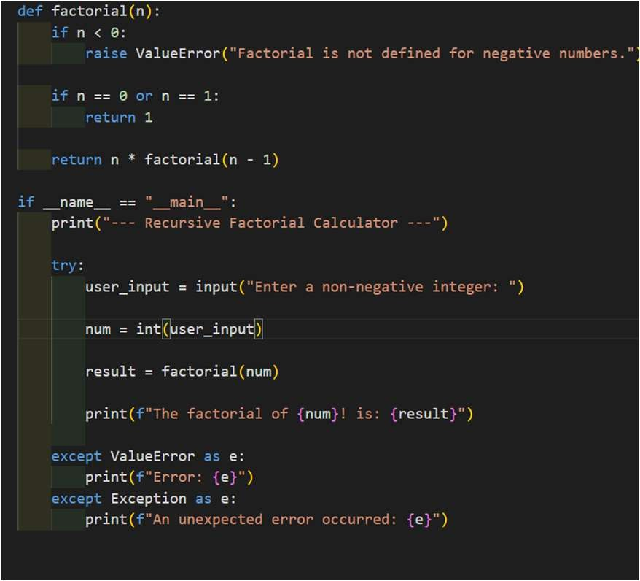
2 convert the above code into java Python code:

Output:

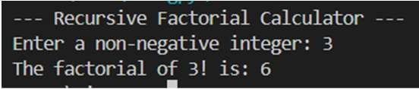

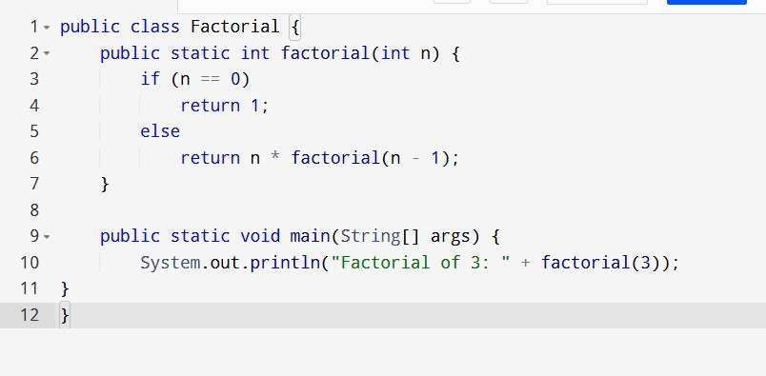
Java code:

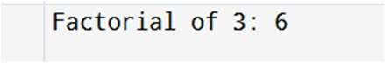
Output:

Explanation:Code Structure
Python: Uses def keyword and indentation for structure Java: Requires class encapsulation and explicit {} bracesEntry Points
Python: Uses if _name_ == "_main_":
Java: Requires public static void main(String[] args) Type System
Python: Dynamic typing with no explicit type declarations Java: Static typing requiring explicit types (int, long, etc.) Integer Handling
Python: Automatic arbitrary-precision integers
Java: Limited integer types requiring explicit long or BigInteger for large factorials

Question-2:
PROMPT: 1 Task: Write a C++ program to sort an array of integers using the Bubble Sort algorithm.
2 convert the above code into python
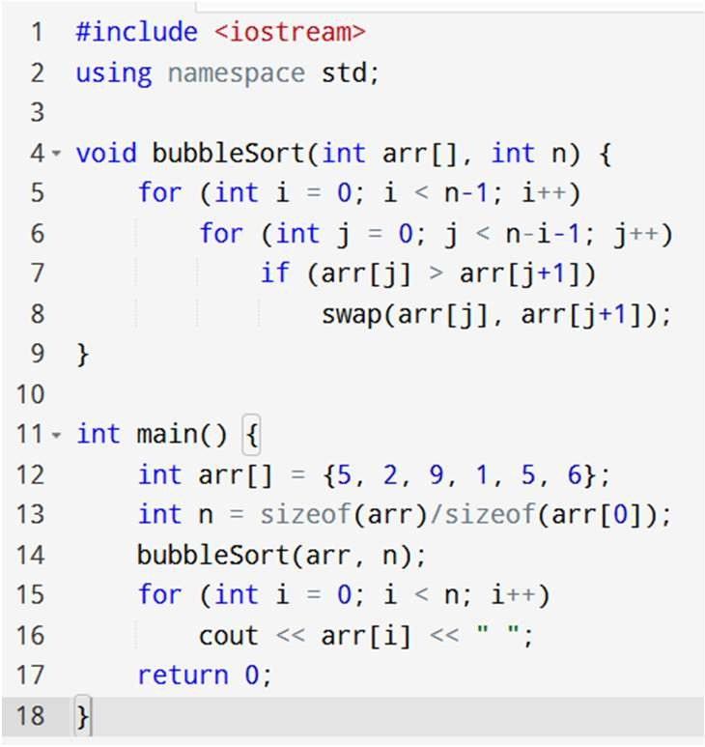
C++ code:

Output:
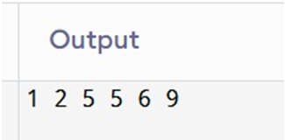

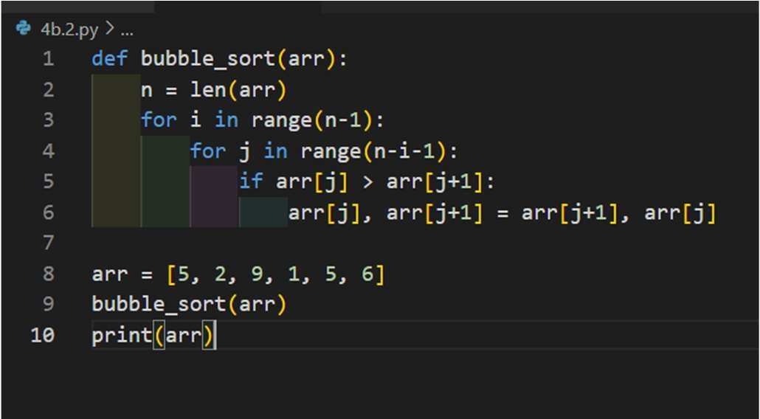
Python code :

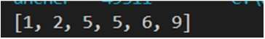
Output:

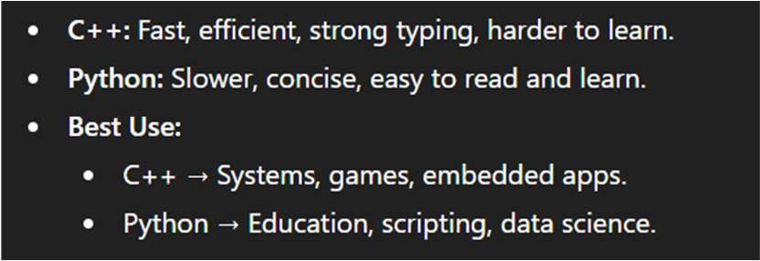
Explanation:

